Computer & Network Systems Wireframes

# Current Website design:

Home:

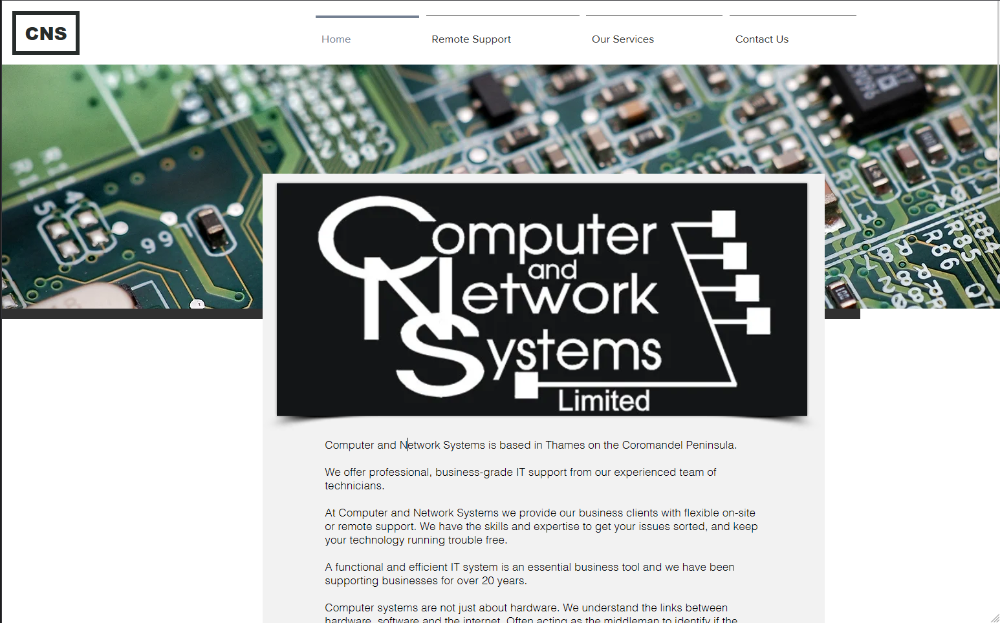

Remote Support:

Our Services:

Contact Us:

# Mock Design

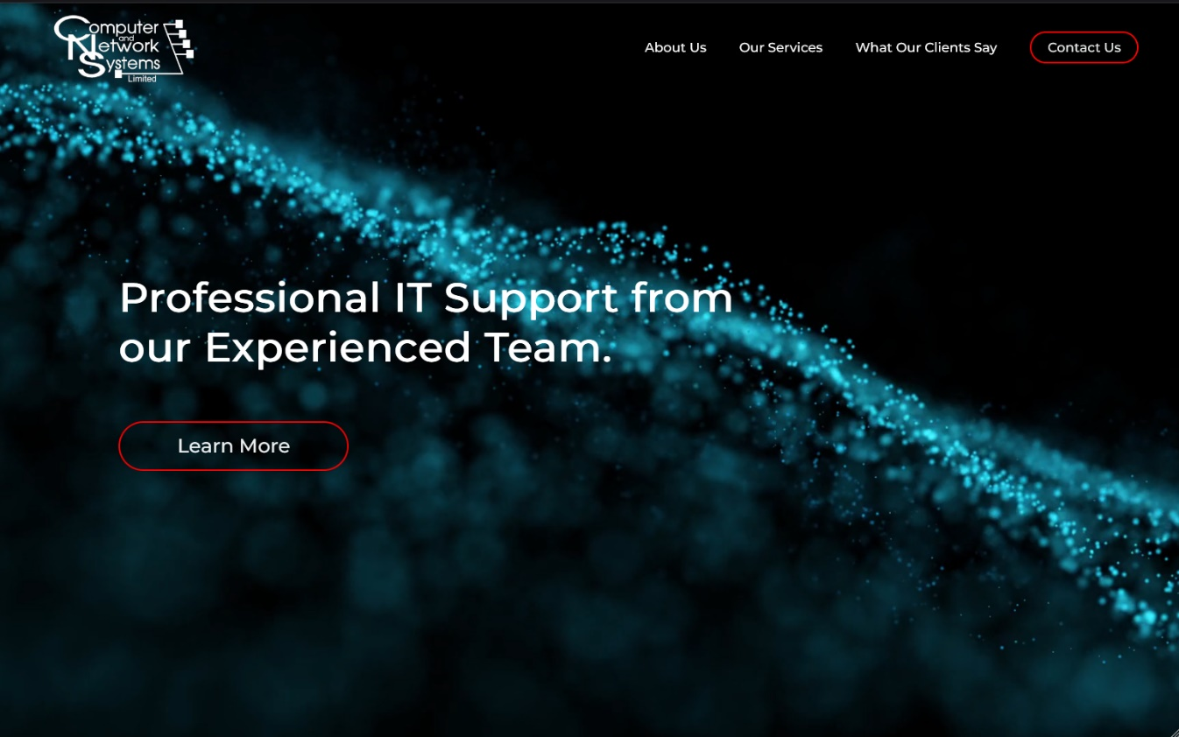

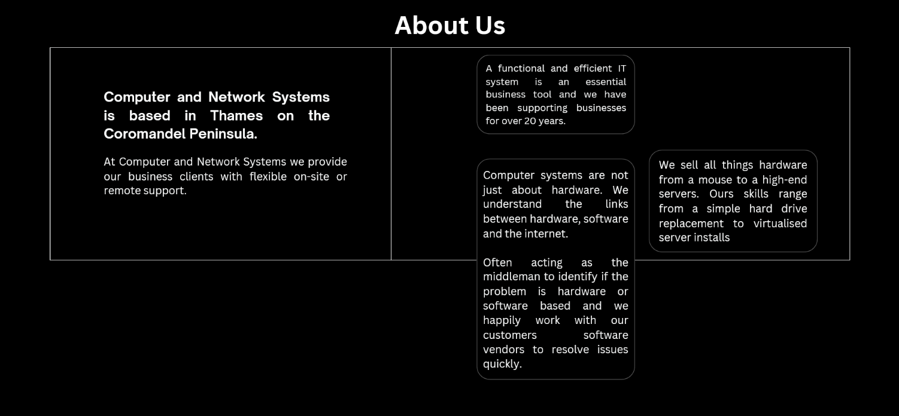

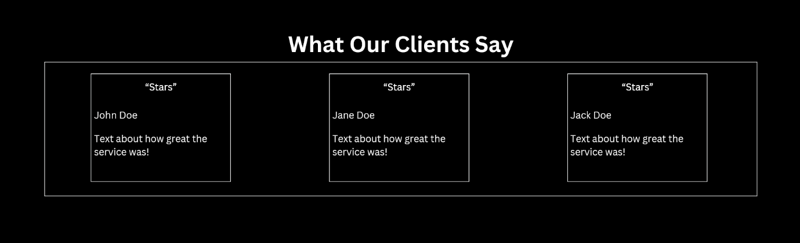

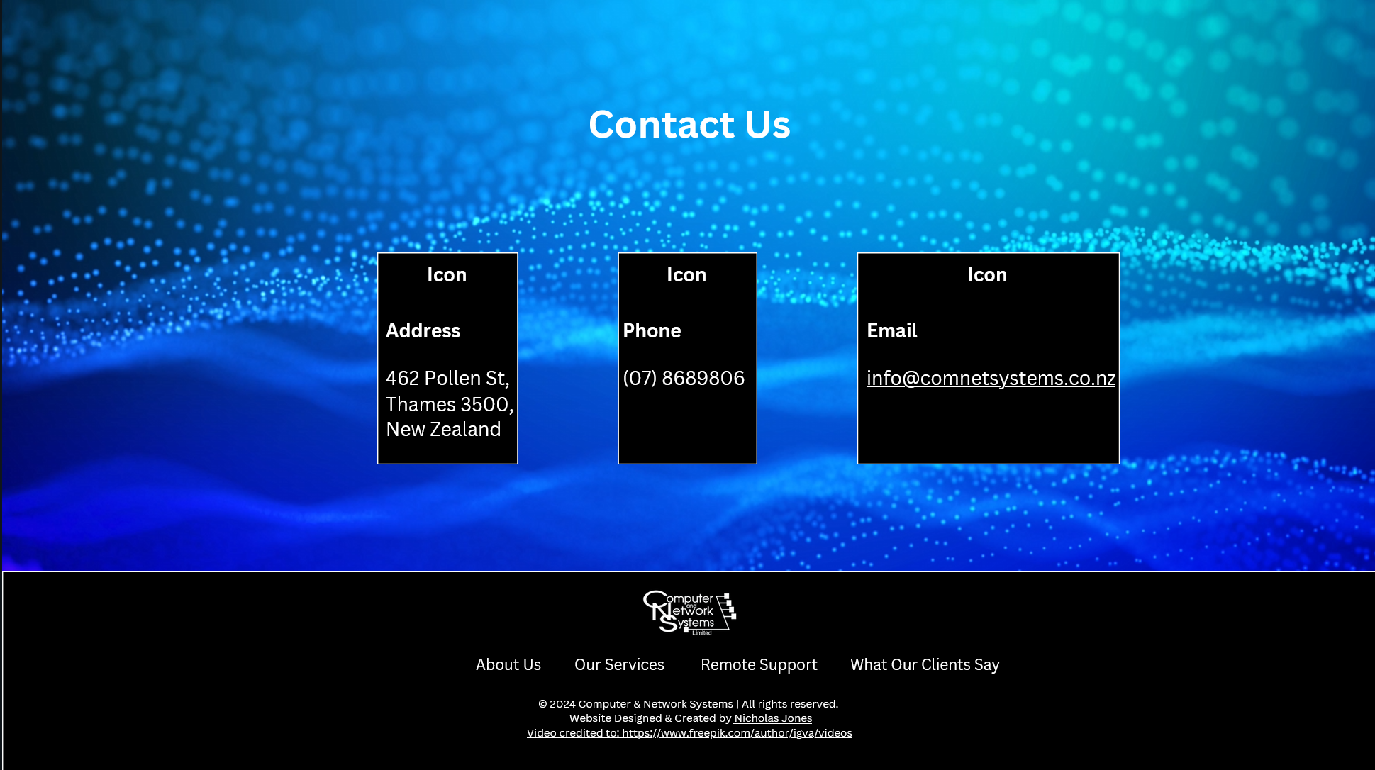

# References

First-page Video:

<a href="https://www.freepik.com/author/igva/videos">Video by igva</a>